Gradient Descent

# Formal Definition

Gradient Descent is an iterative optimization algorithm used to find the minimum of a function. In machine learning and deep learning, it is typically used to minimize a loss function, which measures the difference between the model's predictions and the actual outcomes..

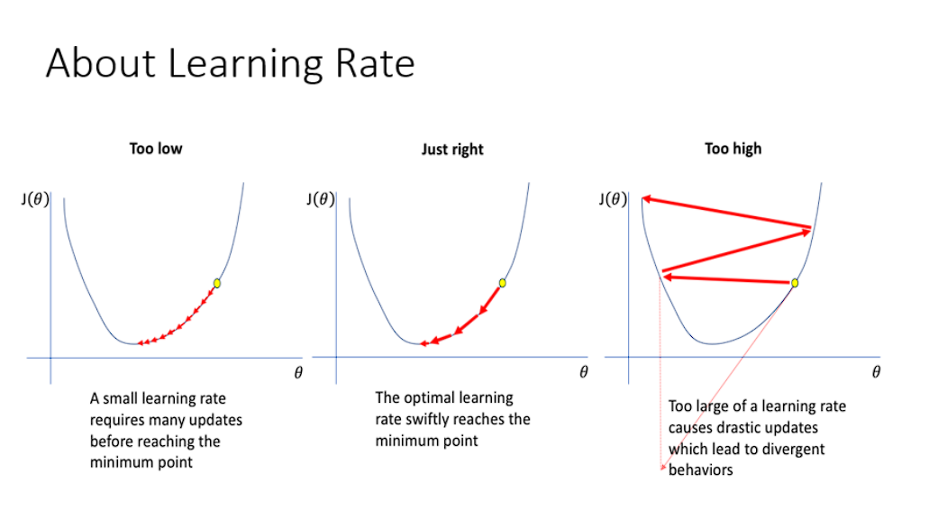

# Layman Explanation

Imagine you're standing on a hill and you want to get to the lowest point (the valley). You don't have a map, but you can feel the steepness of the ground under your feet. By taking small steps downhill in the direction where the ground slopes the steepest, you will eventually reach the bottom.

This is how gradient descent works in machine learning. The hill is the loss function, and your steps represent the adjustments you make to your model's parameters. With each step, you reduce the error in your predictions until you reach the best possible model.

# Examples of Gradient Descent

## 1. Linear Regression

Linear Regression In linear regression, the goal is to find the line that best fits the data. Gradient descent is used to minimize the mean squared error (MSE) between the predicted values and the actual data points by adjusting the slope and intercept.

## 2. Neural Networks

Neural Networks In deep learning, gradient descent is used to update the weights of the network. Each layer's weights are adjusted in a direction that reduces the error in the model's predictions.